**Practical # 3**

**Object: To learn RMI basics: Generate the stubs and skeletons**

**Exercise**

**TASK: 1**

* **Create RMI program in which server performs basic arithmetic operations.**
* **CalculatorInterface.java**

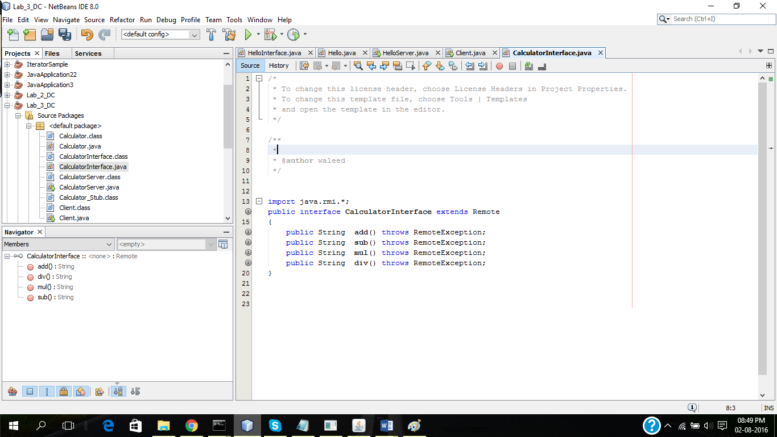

* **Calculator.java**

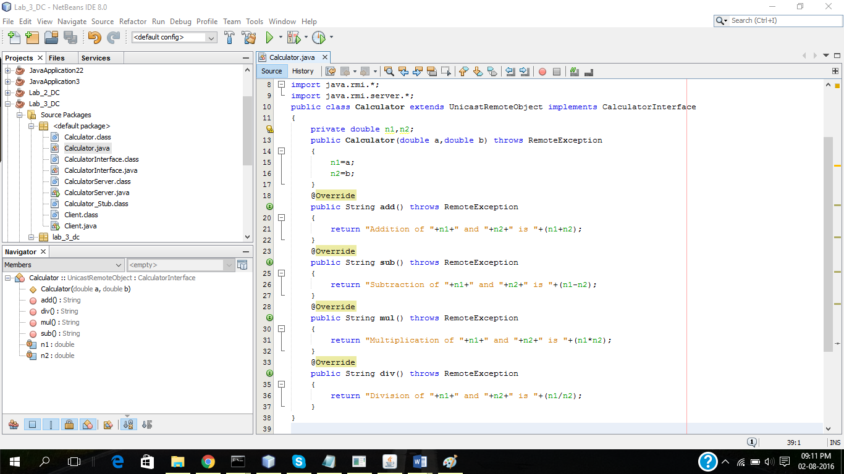

* **CalculatorServer.java**

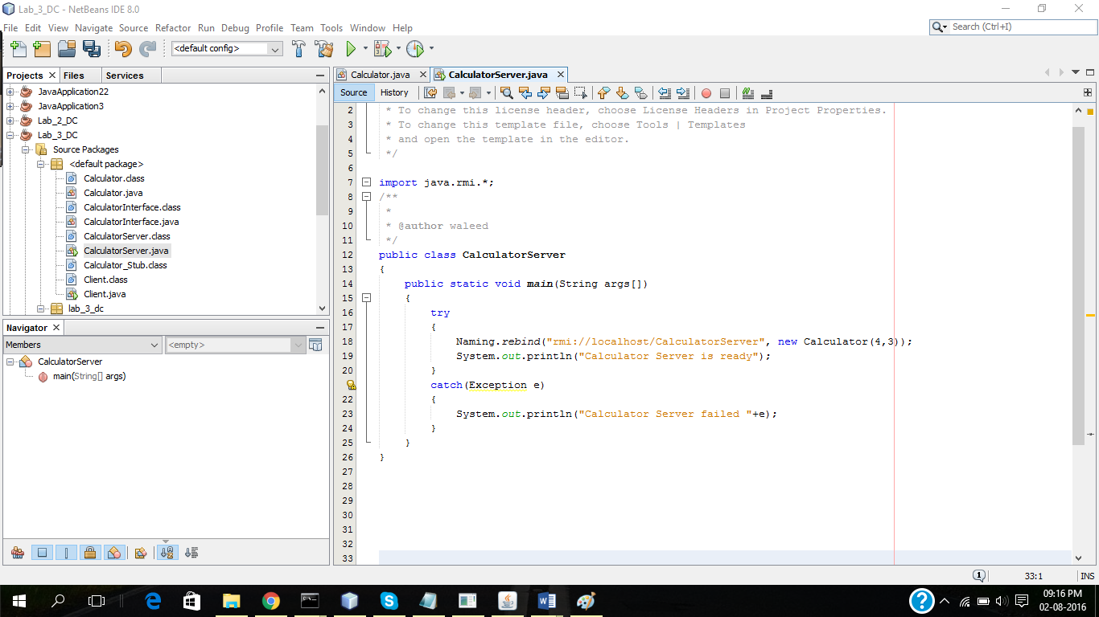

* **Client.java**

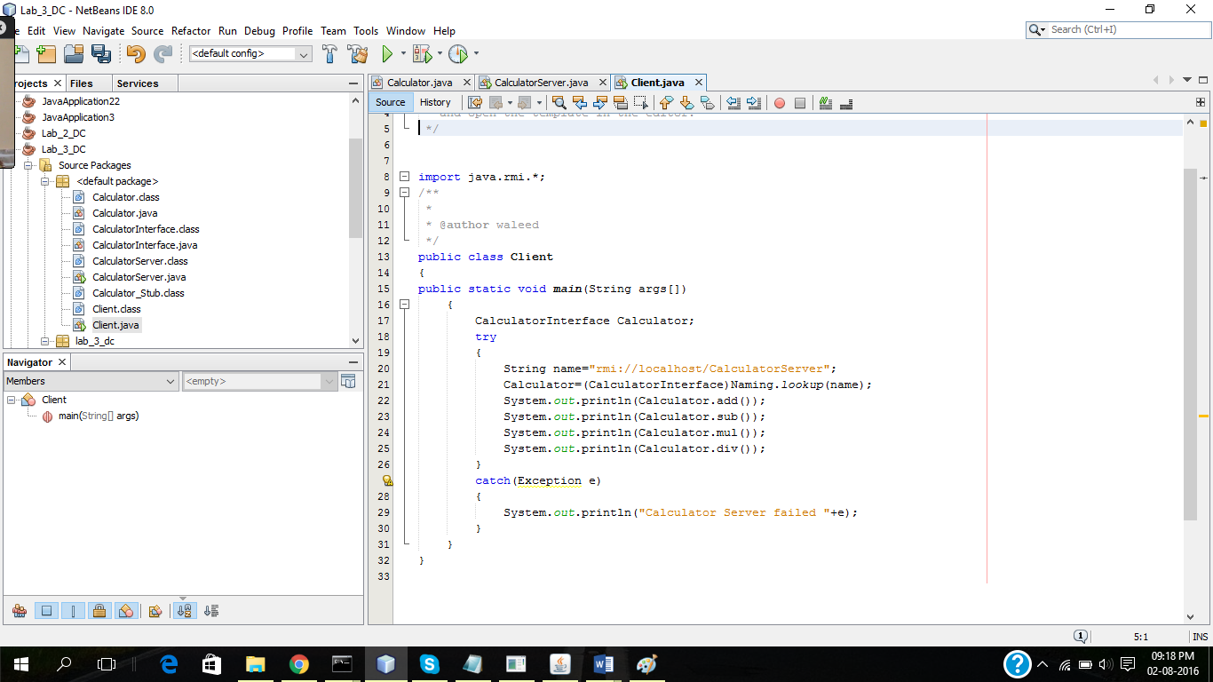

* **Output**

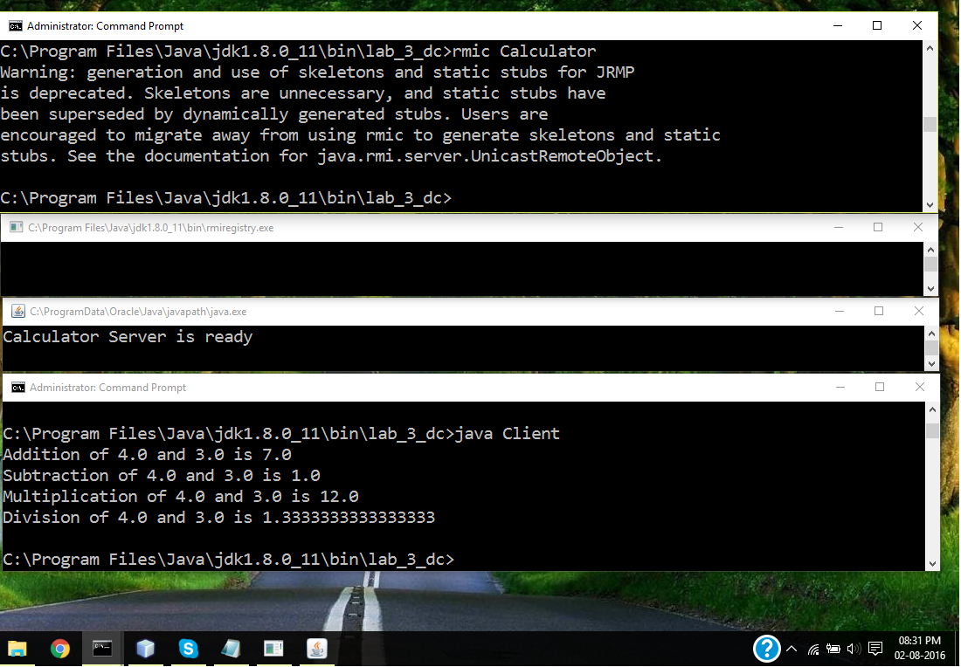

**Task# 2**

* **Create RMI program in which server sorts the numbers in ascending order.**
* **SortingInterface.java**

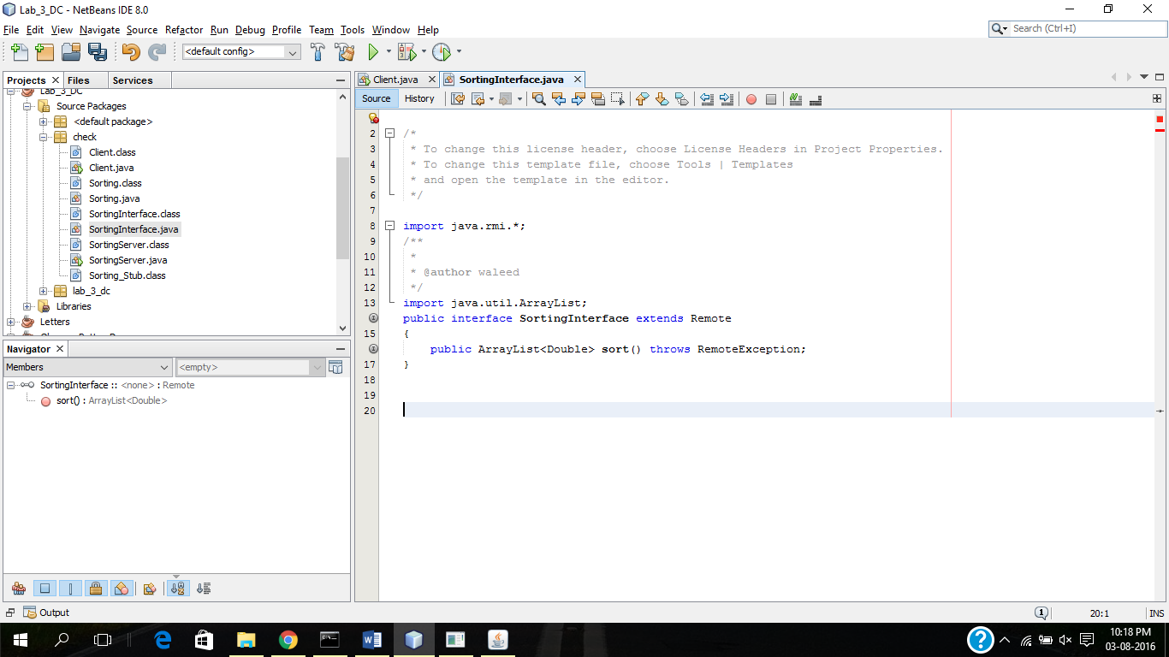

* **Sorting.java**

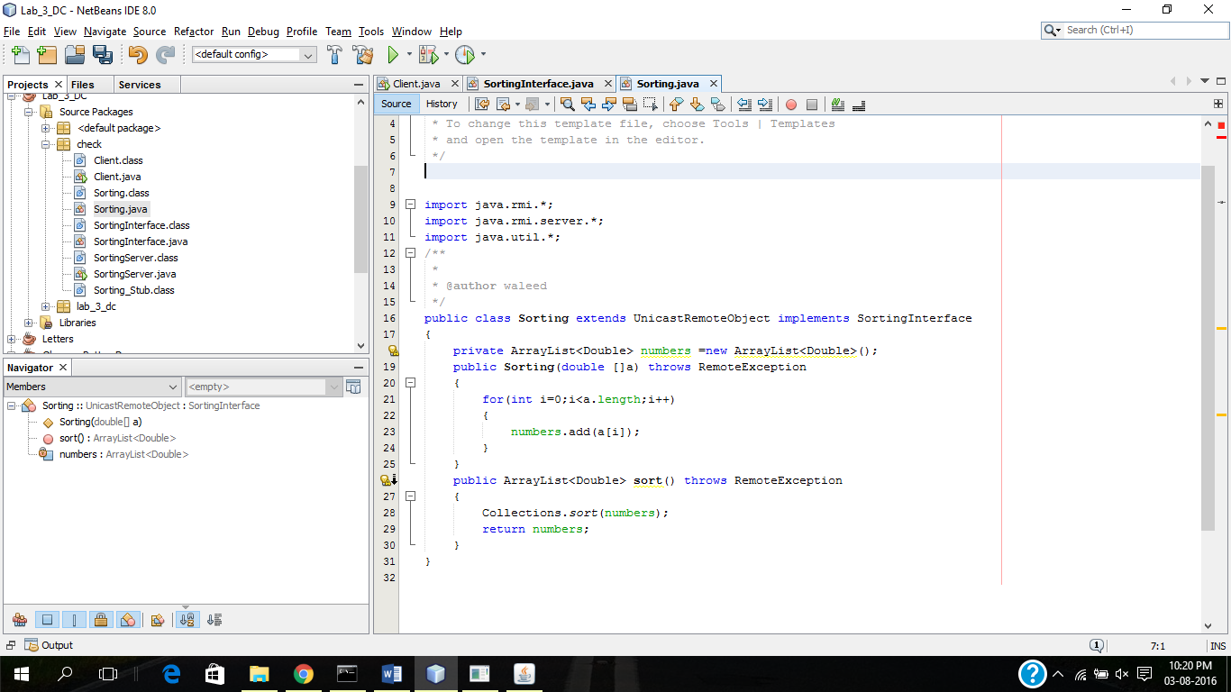

* **SortingServer.java**

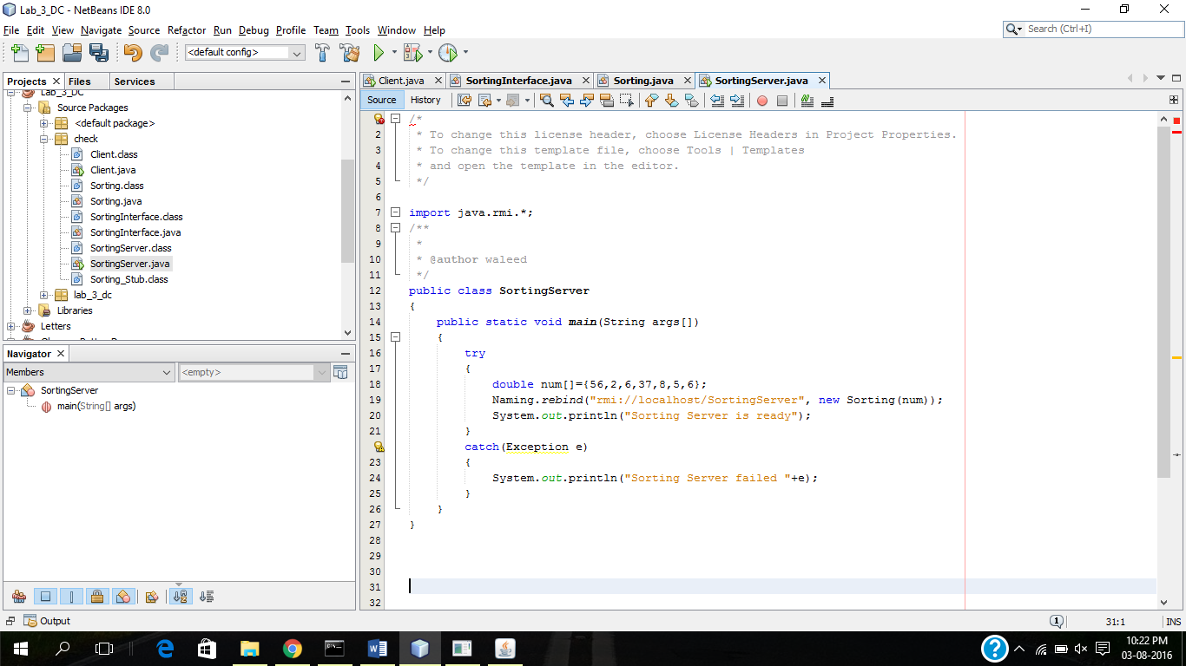

* **Client.java**

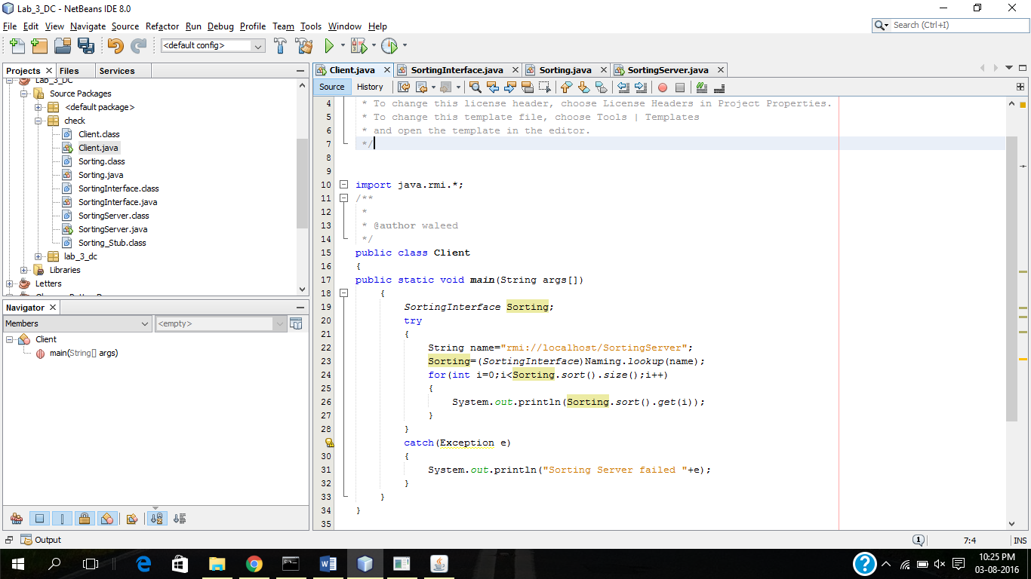

* **Output**

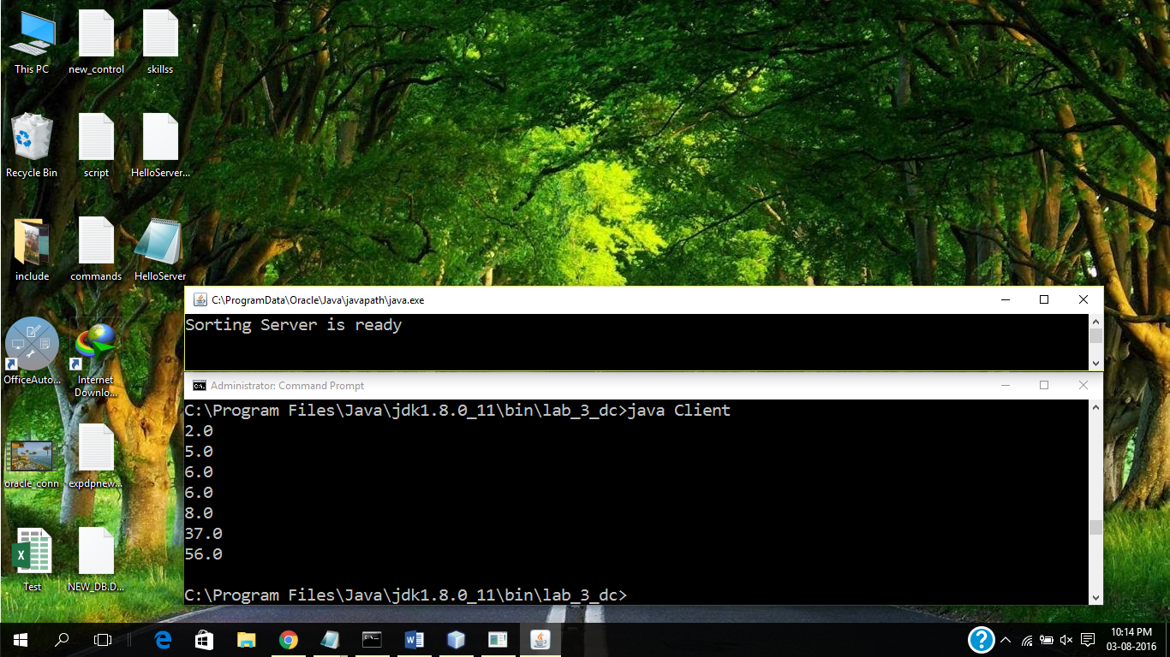

***The End***